Program Upload

- Touch Panel program
《Operation Side》
- Turn the power OFF, and insert the USB memory stick to the USB slot port.

USB Slot

- Turn power ON while you continue pushing the right bottom corner of the screen.

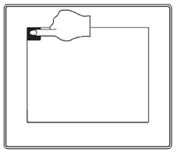

- Push “OK”when the screen asks questions.
Software program uploading will proceed automatically.

- The touch panel re-starts when the program uploading completes. Turn the power OFF when the touch panel restart completes, take the USB memory stick out of the insert port.

